1. Implement an Ethernet LAN using n nodes and set multiple traffic nodes and plot congestion window for different source /destination.

#Make a NS simulator

set ns [new Simulator]

set tf [open lab3.tr w]

$ns trace-all $tf

set nf [open lab3.nam w]

$ns namtrace-all $nf

# Create the nodes,color and label

set n0 [$ns node]

$n0 color "magenta"

$n0 label "src1"

set n1 [$ns node]

$n1 color "red"

set n2 [$ns node]

$n2 color "magenta"

$n2 label "src2"

set n3 [$ns node]

$n3 color "blue"

$n3 label "dest2"

set n4 [$ns node]

$n4 shape square

set n5 [$ns node]

$n5 color "blue"

$n5 label "dest1"

#Creates a lan from a set of nodes given by <nodelist>. Bandwidth, delay #characteristics along with the link-layer, Interface queue, Mac layer and #channel type for the lan also needs to be defined.

$ns make-lan "$n0 $n1 $n2 $n3 $n4" 50Mb 100ms LL Queue/DropTail Mac/802_3

# Create the link

$ns duplex-link $n4 $n5 1Mb 1ms DropTail

# Create the node position

$ns duplex-link-op $n4 $n5 orient right

# Add a TCP sending module to node n0

set tcp0 [new Agent/TCP]

$ns attach-agent $n0 $tcp0

# Setup a FTP traffic generator on "tcp0"

set ftp0 [new Application/FTP]

$ftp0 attach-agent $tcp0

$ftp0 set packetSize_ 500

$ftp0 set interval_ 0.0001

# Add a TCP receiving module to node n5

set sink0 [new Agent/TCPSink]

$ns attach-agent $n5 $sink0

# Direct traffic from "tcp0" to "sink1"

$ns connect $tcp0 $sink0

# Add a TCP sending module to node n2

set tcp1 [new Agent/TCP]

$ns attach-agent $n2 $tcp1

# Setup a FTP traffic generator on "tcp1"

set ftp1 [new Application/FTP]

$ftp1 attach-agent $tcp1

$ftp1 set packetSize_ 600

$ftp1 set interval_ 0.001

# Add a TCP receiving module to node n3

set sink1 [new Agent/TCPSink]

$ns attach-agent $n3 $sink1

# Direct traffic from "tcp1" to "sink1"

$ns connect $tcp1 $sink1

set file1 [open file1.tr w]

$tcp0 attach $file1

set file2 [open file2.tr w]

$tcp1 attach $file2

$tcp0 trace cwnd_

$tcp1 trace cwnd_

# Define a 'finish' procedure

proc finish { } {

global ns nf tf

$ns flush-trace

close $tf

close $nf

exec nam lab3.nam &

exit 0

}

# Schedule start/stop times

$ns at 0.1 "$ftp0 start"

$ns at 5 "$ftp0 stop"

$ns at 7 "$ftp0 start"

$ns at 0.2 "$ftp1 start"

$ns at 8 "$ftp1 stop"

$ns at 14 "$ftp0 stop"

$ns at 10 "$ftp1 start"

$ns at 15 "$ftp1 stop"

# Set simulation end time

$ns at 16 "finish"

$ns run

**AWK:**

BEGIN {

}

{

if($6=="cwnd_")

printf("%f\t%f\t\n",$1,$7);

}

END {

}

Topology:

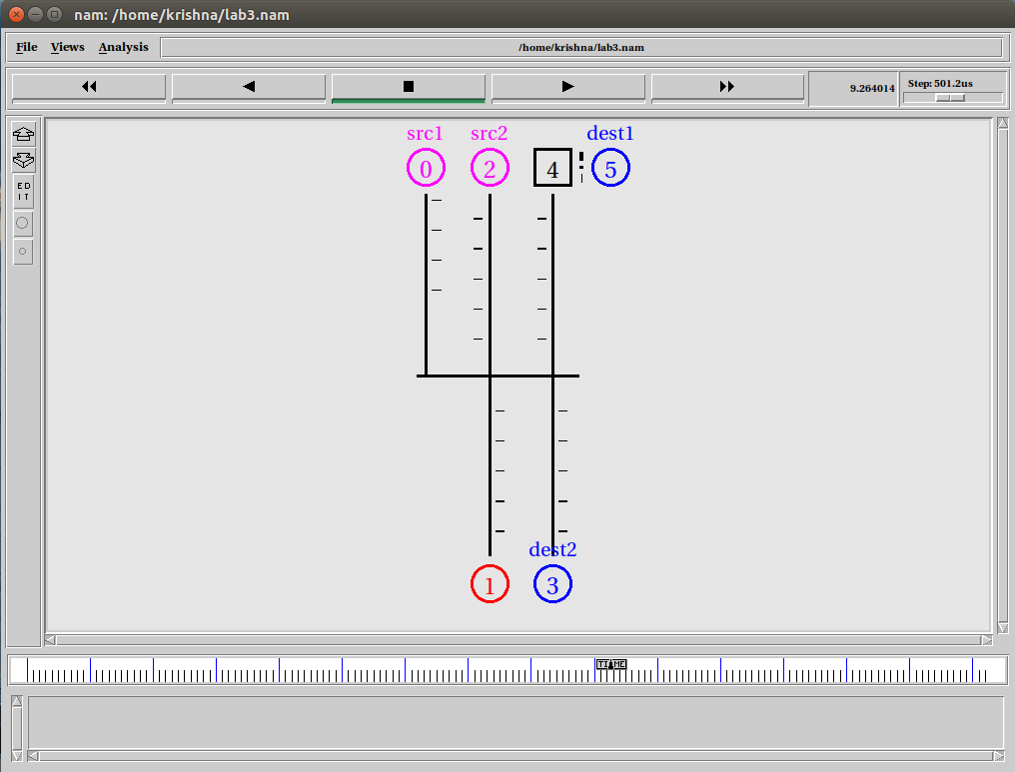

Output: xgraph

